**How to Knit an Octopus**

**Guidance:**

Please use –

* 100% anti-allergenic cotton yarn only – we recommend 4 ply (you may use one or more colours for the body, bottom and tentacles in whatever combination you like).
* Scrap cotton yarn or embroidery thread for eyes, lips, and (optional) additional attributes.
* Anti-allergenic toy filling/stuffing, preferably washable at 60 degrees (it is important to make sure that the filling does not go through the stitches).

**Other Materials and Tools:**

* Needles 2,25 mm /US 1/ UK 13
* Darning needle

**Size of the finished octopus:**

Head should be 6-9 cm/ 2.5-3.5 inches from top to bottom

Tentacles should not be more than 22 cm / 8.5 inches when stretched

**Abbreviations:**

CO/ BO – Cast on/ bind off

kfb – Knit through the front loop and then through the back loop of the same stitch; increase

k2tg – Knit two stitches together; decrease

sl1-k2tg-psso – Slip one stitch knitwise, knit two stitches together, pass the slipped stitch over the stitches knitted together; decrease

ssk – Slip one stitch knitwise, slip another stitch knitwise, put those two stitches back on your left needle and knit them two together through their back loops; decrease

*…* (3) – Work instructions given between the asterisks three times R row

[10 sts] – Number of stitches after the certain round is finished

**Instructions**

**Body and tentacles:**

CO 22 sts.

R 1 k22, CO 40 sts, turn [62 sts]  
R 2 k60, turn  
R 3 k18, turn  
R 4 k16, turn  
R 5 k14, turn  
R 6 k13, turn  
R 7 k11, turn  
R 8 k9, turn  
R 9 k15, 40kfb [102 sts]  
R 10 BO80, k21, turn  
R 11 k22, CO 40sts

Work R 2 – R 11 six times more, then R 2 – R 9 again, and finally, in R 10 bind off all stitches. Cut the remaining yarn leaving a tail long enough so you could join the CO and BO rows.

Here is how k22 in R 1 and R 11 looks like when done:



And here is how your work should look like when you CO 40 in R 1 and R 11:



**Bottom:**

CO 3 sts.

R 1 knit all stitches  
R 2 kfb, k1, kfb [5 sts]  
R 3 knit all stitches  
R 4 kfb, k3, kfb [7 sts]  
R 5   
 | knit all stitches   
R 8   
R 9 k1, k2tg, k1, ssk, k1 [5 sts]  
R 10 knit all stitches  
R 11 k1, sl1-k2tg-psso, k1 [3 sts]   
R 12 knit all stitches  
R 13 BO

**Assembling the body:**

When the body is ready, use the yarn tail to graft the cast-on row with the bind-off row.

Cut the remaining yarn leaving a tail long enough to join the bottom piece with the body. Put the filling inside the octo’s body and using a darning needle fasten the bottom to the body.

Note that the octo’s body and the bottom (the next two photos on the following page) need to be grafted together once the filling is already inside of the body.



To close the top of the body, weave in the yarn end around the edge of the top stitches to pull them together and close the top of the head.

** **

 



Using scrap yarn, embroider eyes and mouth. Use your imagination for working out additional elements.

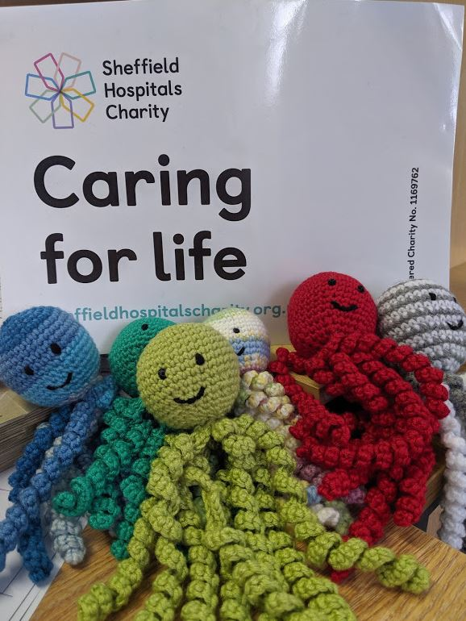

**Please either arrange a drop off time or send all completed Octopi to:**

**Office Se6, Leah's Yard, Cambridge Street, Sheffield, S1 4HP**